
Lesson 5 Teacher's Key
Unreal
INSTRUCTOR ONLY - do not distribute to students

Level 1 - Complete Worked Solution
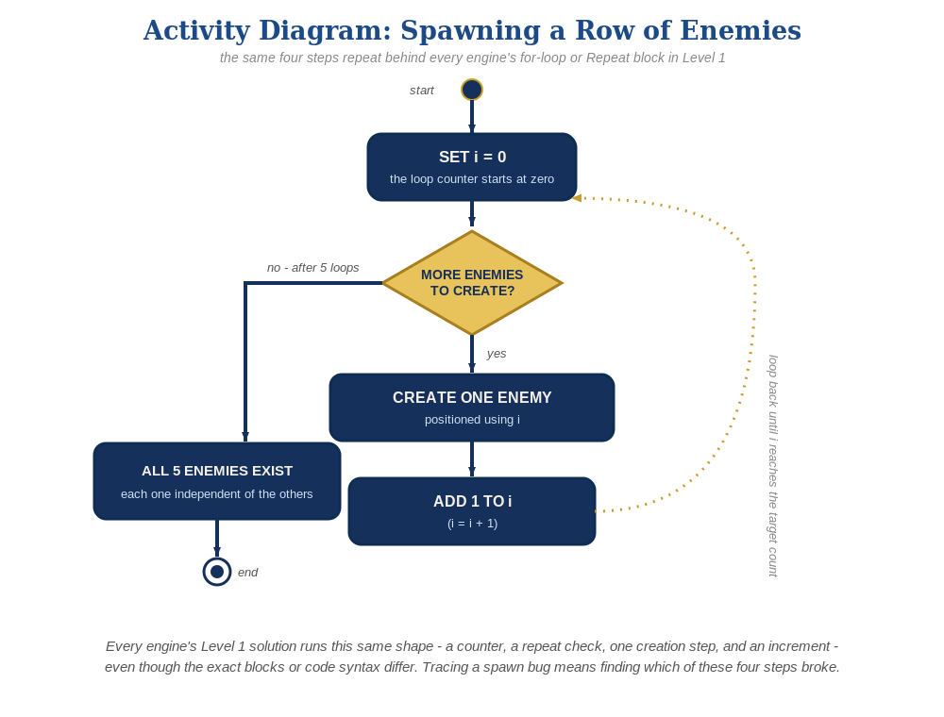
The spawn loop, in general - the same counter, repeat check, creation step, and increment behind Level 1 in every engine, whatever the exact blocks or syntax look like.
A For Loop node in the Level Blueprint - BP_Enemy needs zero changes from Lesson 4:
Level Blueprint:
Event BeginPlay ->
For Loop(First Index = 0, Last Index = 4) ->
Spawn Actor from Class(BP_Enemy, Transform.Location = (BaseX + Index * 150, BaseY, 0))
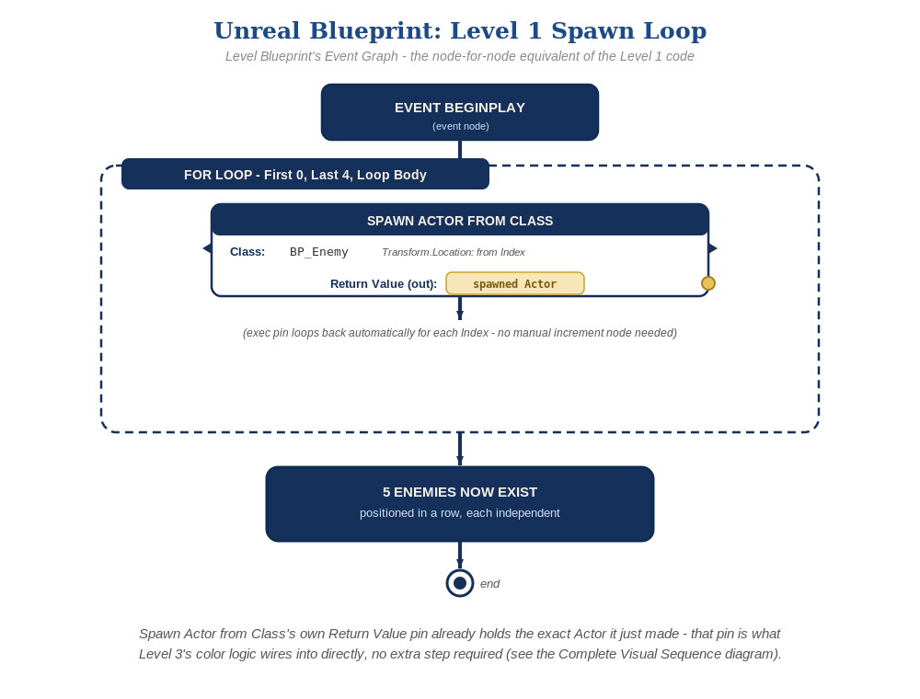
The Level Blueprint's Event Graph, node by node - the node-for-node equivalent of the Level 1 nodes above.

Level 2 - Complete Worked Solution
BP_Enemy's own Event ActorBeginOverlap and Cast To BP_Bullet logic is fully self-contained per instance, so every Actor the loop spawns behaves independently and correctly with no extra nodes needed for Level 2.

Level 3 - All Worked Solutions
Every stretch-goal idea from the handout, fully worked - not just one. Useful for validating each idea actually works before class, and as a ready reference no matter which one a student ends up picking.

Sound: already works
The Play Sound 2D node inside BP_Enemy's overlap event runs independently for every enemy that gets hit - no changes needed.

Visual: striped row
Add a custom Event (e.g. SetStripeColor) to BP_Enemy that creates its dynamic material instance with a passed-in color, then call it from the Level Blueprint's loop right after each Spawn Actor from Class, alternating colors based on Index. Build Dark Red and Light Red with a Make Linear Color node, not Make Color - Set Vector Parameter Value expects a Linear Color, whose R/G/B fields are 0-1 floats, not Make Color's 0-255 bytes: Dark Red = R 0.8, G 0.1, B 0.2 (a deep crimson red), Light Red = R 0.95, G 0.4, B 0.5 (a lighter dusty rose/pink) - the same two shades used in this course's Unity/Godot tracks, just as a 0-1 float here instead of 0-255:
BP_Enemy: Custom Event SetStripeColor(Color) ->
Create Dynamic Material Instance(Self's Material) -> Set Vector Parameter Value("Color", Color)
Level Blueprint:
Dark Red = Make Linear Color(R=0.8, G=0.1, B=0.2)
Light Red = Make Linear Color(R=0.95, G=0.4, B=0.5)
Inside the For Loop:
Spawn Actor from Class(BP_Enemy, ...) -> (Return Value) -> SetStripeColor(Index % 2 == 0 ? Dark Red : Light Red)

Structure: spawner vs. behavior stay separate
The Level Blueprint's For Loop only ever spawns and positions enemies - collision-response and hit-sound logic stay entirely inside BP_Enemy's own Event Graph.

Complete Level 3 solution (all 3 goals combined)
The spawn loop with the visual idea added - sound needs no changes since it already lives on BP_Enemy:
BP_Enemy: Custom Event SetStripeColor(Color) ->
Create Dynamic Material Instance(Self's Material) -> Set Vector Parameter Value("Color", Color)
Level Blueprint:
Dark Red = Make Linear Color(R=0.8, G=0.1, B=0.2)
Light Red = Make Linear Color(R=0.95, G=0.4, B=0.5)
Event BeginPlay ->
For Loop(First Index = 0, Last Index = 4) ->
Spawn Actor from Class(BP_Enemy, Transform.Location = (BaseX + Index * 150, BaseY, 0))
-> (Return Value) -> SetStripeColor(Index % 2 == 0 ? Dark Red : Light Red)

Complete Visual Sequence (all nodes combined)
Every node in the Complete Level 3 solution above, wired in the order it actually runs.
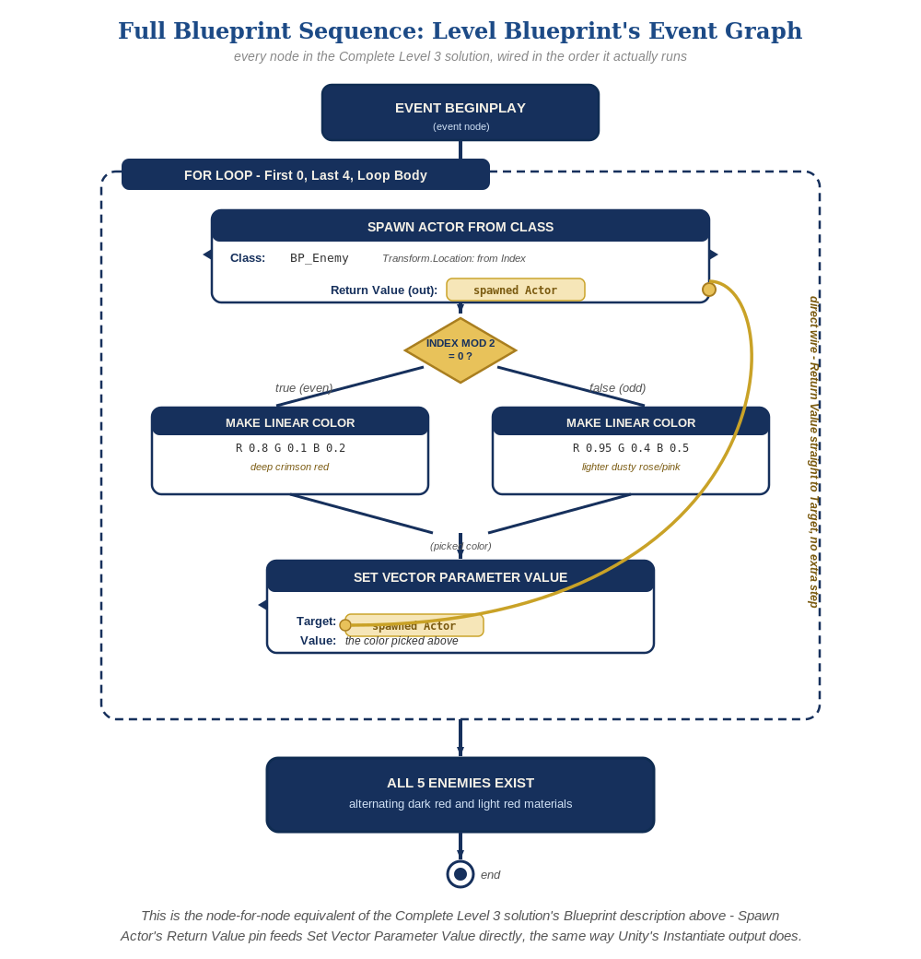
Spawn Actor from Class's own Return Value pin plugs straight into Set Vector Parameter Value's Target - the same direct-wire pattern as Unity's Instantiate, no promote-to-variable step needed.

Alternate Path Notes: C++
A plain C++ for loop calling GetWorld()->SpawnActor<ACppEnemy>() several times is the code equivalent of the Blueprint For Loop node.
The Level 3 visual idea maps onto a public method on ACppEnemy called right after each SpawnActor call - Sound needs no changes either way, since it lives on ACppEnemy's own OnOverlap(), not the spawner.
- Showing both C++ and Blueprint side by side for the same behavior keeps demystifying Blueprints for students who assume "visual" means "not real code" - it's the same engine calls either way.
- This is squarely the optional advanced track - most students should stay on Blueprints; C++ is for students already comfortable with typed languages from Godot, GameMaker, or Unity's C# path.

